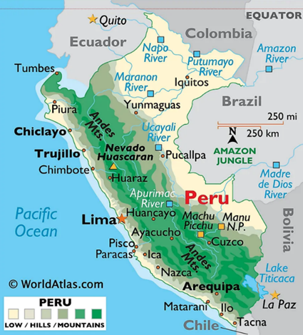

Journey with FF Sarasota

Are you ready for a fantastic journey experience with Friendship Force Sarasota to FF NorPer-Trujillo and FF Lima, Peru May 8-21, 2024? We estimate the cost of this journey to be $1200.

Journey Number: 24069, Ambassador Coordinator (AC) Diana Friedman, (941) 374-9512, diana_friedman@aol.com

